District of North Vancouver
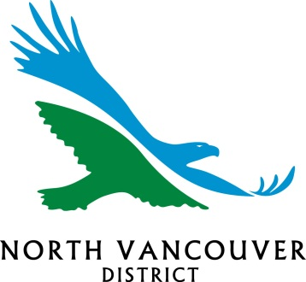

ASSET MANAGEMENT STRATEGY
2018
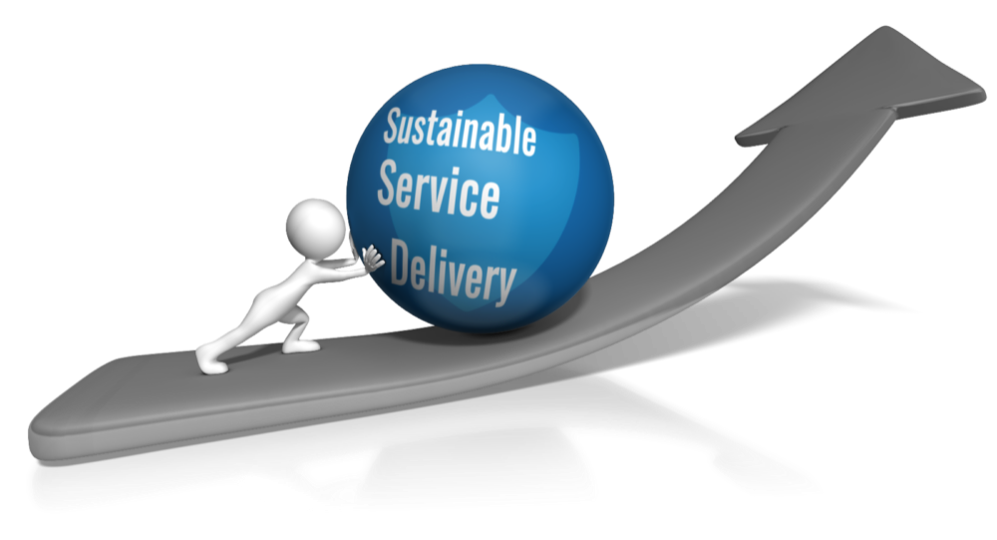

Document Control

Document Control |  | NAMS.PLUS Asset Management    www.ipwea.org.au/namsplus
Document ID: EDoc #3105408
Rev No | Date | Revision Details/Doc # | Author | Reviewer | Approver
#1 | Jan/16/2018 | Annual Update - draft | AZ | AW | AW
#2 | Feb/21/2018 | Annual update - final | AZ | AW/AMSC | AW

Contents

Executive Summary 1
1.1 Legislative reform 7
1.2 Asset Management Planning Process 8
2. What Assets do we have? 9
3. District Assets and their management 10
3.1 State of the Assets 10
3.2 Life Cycle Cost 15
3.3 Asset Sustainability 17
3.4 Asset Management Structure 18
3.5 Corporate Asset Management Team 18
3.6 Financial & Asset Management Core Competencies 19
3.7 Strategy Outlook 19
4.1 Council’s Vision, Mission, Goals and Objectives 20
4.2 Asset Management Policy 21
4.3 Asset Management Vision 21
6. Asset Management Improvement Plan 24
Appendix A Asset Management Maturity Assessment 26

This page is left intentionally blank

Executive Summary
This Asset Management Strategy assists Council in meeting community requirements using international best practices in asset management, long term financial planning, emerging sustainability frameworks that focus on corporate responsibilities and providing services in a financially sustainable manner.
The Asset Management Strategy is prepared to assist the District in improving the way it delivers services from infrastructure including roads, bridges, culverts, water, sewerage, stormwater drainage, parks and recreation, buildings and other assets. District assets that comprise of renewal capital (the current “built environment”) have a 2017 replacement value of approximately $2.1 Billion.
This Asset Management Strategy will:
- Present how the asset portfolio will help meet the service delivery needs of the community into the future,
- Enable Council’s asset management policy to be achieved, and
- Ensure the integration of the District’s asset management into long term financial plans.,
One of the key challenges facing Council is how to sustainably balance investment in new asset intensive services with the need to maintain existing asset intensive services at levels of cost and quality that are acceptable to the community. Building a sustainable community requires an effective asset management regime that applies a combination of management, financial, economic, engineering, ecological and other practices to the built environment. The term “asset management” in this context means the process by which Council manages its built environment (including long lived infrastructure) to achieve a balance between the community’s service expectations and their willingness and capacity to pay for the infrastructure and land assets that underpin these services.
The concepts most people use in their personal and business lives are basically the same as those that should be applied to local government, but need some modification. This is because local Governments are perpetual corporations which acquire and manage a stock of financial and physical assets (including renewing and disposing of individual items) in order to provide services for generation after generation of local residents and ratepayers.
Local governments provide the legal framework by which communities own infrastructure and other assets and by which they act as a collective. Much local government infrastructure has a life of 30, 50 or in some cases well over 100 years. While individuals involved may come and go, local government continues, like Provincial and Federal governments, perpetually.
For local government, considering financial sustainability poses the question:
“Can we continue the sort of revenue and expenditure patterns of recent years while maintaining the levels of service expected by the community?”
The perpetual nature of local government means that every local government carries stewardship responsibilities that sustain the “built environment” at a reasonably consistent rate, at the lowest cost, over each assets life cycle. To that end asset management best practices support agreed upon levels of service using steady state replacement of the existing “built environment” augmented by holistic and reasonable levels of debt.
Moving forward there are opportunities to renew assets and services through the implementation of the Official Community Plan.
The District is well positioned to sustain the current levels of service for the next ten years. Starting in 2004, Council began to address its infrastructure backlog by placing 1% on the tax levy dedicated to sustaining the built environment. The focus of this tax strategy is to build stable financial resiliency that supports the “steady state funding” of the built environment.
The District monitors steady state funding using best practice financial ratios the most important measure being the Operating Surplus Ratio. The Operating Surplus Ratio is based on a foundation of audited financial statements amended to remove one time funding and replace historical cost depreciation with current replacement value deprecation (representative of asset consumption). The District is currently in the best practice benchmark range. Draft operating surplus ratio is shown below:
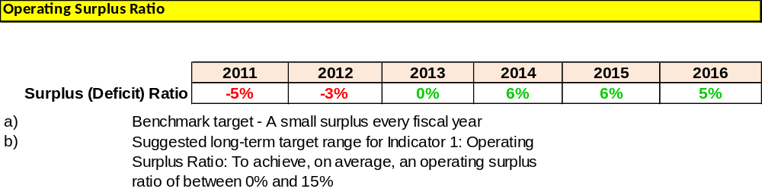
Asset inventory data is compliant with ISO 55000 Series Asset Management, ISO 31000 Risk Management and Public Sector Account Board Standards. Asset additions and disposals are subject to the annual external audit.
The cost to bring infrastructure measured primarily in “Poor” and “Very Poor” condition back to satisfactory levels of service is estimated at $100 million (5% of our total asset base). Funding this “backlog” is addressed through the “1% Asset Renewal” policy and progress can be measured through the “Operating Surplus Ratio”. Management believes this can be managed and current service levels sustained over the next ten years. Annual capital funding is currently $35 million.
The goal is steady state replacement of existing assets over time. Management estimates we are close to this objective for the existing built environment. District asset management plans assess the entire asset life cycle cost of the built environment. Beyond the current ten year long term financial planning horizon, costs will continue to rise particularly in District Buildings, Sanitary and Drainage systems. Steady state replacement strategies combined with best practice reserve levels augmented by strategic use of debt financing of major building renewals should address these longer term costs.
Over the course of the next ten years Council and management will shift focus beyond sustaining the existing built environment to:
- Fulfilling the OCP vision,
- Addressing gaps in key strategic plans,
- Prioritization of community demands for asset upgrades, new assets and related maintenance and operating costs that support increased levels of service from infrastructure as the community changes and the asset inventory grows.
These changes will bring additional fiscal pressures as both community vision and expectations are fulfilled.
Council’s current asset management maturity is near ‘core’ levels. Core levels are defined as achieving National Asset Management Strategy fundamentals. For greater clarity, Core levels are not advanced asset management. Further core work is needed to improve data and systems, levels of service management, reporting, accountability and direction.
This Asset Management Strategy is typically updated following a review of service delivery practices, financial sustainability indicators, asset management maturity assessments and fit with the District’s vision for the future outlined in the Official Community Plan, Identity DNV 2030. This strategy outlines an Asset Management Improvement Plan detailing a program of tasks to be completed and resources required to sustain the District at a minimum ‘core’ level of asset maturity and competence. The Asset Management Steering Committee will initiate a Levels of Service Review in 2017/18. This will be the first time this has been done using international best practices. This review will be pilot project based including staff training and two major asset groups.
Population growth, local conditions, resiliency of the natural and built environments, changing demographics (such as an aging population), rising customer expectations, competing demands for funding and an increasingly demanding external regulatory environment all impact the existing asset base (built environment). Other considerations include the need for secondary sewage treatment, climate change, natural hazards and rising sea levels. Over the long term it is essential that well-informed asset management decisions focus on sustaining agreed upon levels of service and the built environment. These decisions, which involve setting service levels, costs and priorities for asset based services may have far reaching social, environmental and financial implications for the District.
Strategy outlook
Asset management strategies
No | Strategy | Desired Outcome
1 | Measurable progress toward the Asset Management Vision and Mission (see section 4.3) moving toward agreed upon service levels. | The long term implications of Council services and the built environment are considered in annual budget deliberations.
2 | Conduct an annual high level review of Council’s levels of service working first with internal stakeholders then other stakeholders. | Appropriate resources to deliver services
3 | Develop and annually review Asset Management Plans (AMP) covering asset life cycles (minimum term of 10 years) for all major asset classes. | Infrastructure needed by the community and required funding to optimise ‘whole of life’ costs.
4 | Develop annually a Long Term Financial Plan covering at least 10 years incorporating asset management plan expenditure projections with a sustainable funding position outcome. | Sustainable funding model to provide Council services.
5 | Integrating AMPs into the LTFP Incorporate Year 1 of Long Term Financial Plan revenue and expenditure projections into annual budgets. | Long term asset and financial planning drives budget deliberations.
6 | Annually review and update Asset Management Plans and the Long Term Financial Plan after adoption of annual budgets. Communicate any consequence of funding decisions on service levels and service risks. | Council and the community are aware of changes to service levels and costs arising from budget decisions.
7 | Report Council’s financial position at Replacement Value using Australia’s National Asset Management Strategy (NAMS), the Australian Local Government Financial Sustainability Indicators and performance against strategic objectives in Annual Reports. Assets and depreciation leverage Canadian Public Sector Accounting Board standards but include replacement value. | Financial sustainability information is available for Council and the community.
8 | Ensure Council’s decisions are made from accurate and current information in asset registers, on service level performance and costs and ’whole of life’ costs. | Improved decision making and greater value for money.
9 | Report on Council’s resources and operational capability to deliver the services needed by the community in the Annual Report. | Services delivery is matched to available resources and operational capabilities.
10 | Ensure responsibilities for asset management are identified and incorporated into staff position descriptions. | Responsibility for asset management is defined.
11 | Leverage this AM Strategy, the Asset Management Steering Committee and Executive Sponsors to realise, then sustain, ‘core’ maturity for the financial and asset management competencies. | Improved financial and asset management capacity within the District.
12 | Report to the Finance & Audit Committee of Council on asset management milestones, AM Strategy, AM Plans and LTFP. | Oversight of resource allocation and performance.
Asset management improvement plan
The program of tasks and resources required to achieve a minimum ‘core’ asset management maturity supports the asset management strategy. The tasks and program are shown below.
AMBC Roadmap | Ref | Task – with AMBC Roadmap reference | Responsibility | Target | Budget
1.0 Know your assets | 1 | 1.6 Data, software and tools strategy  Start AM process and technology improvement: capital planning process (GFOA whitepaper) and capital planning and analysis (Hubble Upgrade) | Andrew Zhou / Andrew Durnin | TBD | Existing + additional resources
2.0 Know your financial situation | 2 | 2.7 optimized capital plan  Complete 10 year Long Term Financial Plan for 2019-2028, and workshop for Council | Rick Danyluk | Spring 2019 | Existing Resources
4.0 Manage your asset lifecycle,  2.0 Know your financial situation | 3 | 4.5 lifecycle strategies – OM, renewal and new  2.3/2.5 future capital and OM costs  Update Asset Management Plans including new AMP for fleet and NSEMO; focus on OM analysis and impact | Asset Managers | Summer 2018 | Existing Resources
4.0 Manage your asset lifecycle,  1.0 Know your assets | 4 | 4.7 optimize treatment selections  1.6 Data, software and tools strategy  Storm water AM system: CAMN (Climate change and Asset Management Network) – FCM funded project, phase 2, lifecycle management | Stephen Bridger/Andrew Zhou | June 2019 | Existing Resources
5.0 Know the rules | 5 | 5.1 Strategic goals  Project prioritization, refresh case template, sample high level case, OCP Implementation review | Felim  Victoria  Dan | Summer 2018 | Existing Resources
5.0 Know the rules, | 6 | 5.2 Legislation, regulation, policy & standards  Revise AM policy, AM strategy and AM governance framework: CAMN (Climate change and Asset Management Network) – FCM funded project, phase 1 | AMSC | May 2018 and Jan 2019 | Existing Resources
6.0 Sustainability monitoring | 7 | 6.1 Sustainability assessment  Update and report out on key financial sustainability indicators through Annual Report – AMSC to produce five-year forecast with a focus on the Asset Sustainability Ratio (ASR) | Andy Wardell/ Charlene Grant  AMSC | Spring 2018 | Existing Resources
6.0 Sustainability monitoring | 8 | 6.3 demand management – alternative strategies  Explore options for accelerated implementation of some programs (e.g. Active Transportation) | Steve Ono, Larry Davis | TBD | Existing Resources
6.0 Sustainability monitoring | 9 | 6.2 Coordinating infrastructure works  Project management framework – based on review of best practices | Victoria | 2018-2019 | Existing + additional resources
6.0 Sustainability monitoring | 10 | 6.4 Emerging technology (innovation)  AMBC & GFOABC joint training session – ½ day workshop for GFOABC in fall 2018 | TBD | TBD | Revenue potential
1. Introduction
The objective of this Asset Management Strategy is to establish a framework to guide the planning, construction, maintenance and operation of infrastructure essential for Council to provide services to the community. Assets deliver important services to communities. A key issue facing local governments throughout Canada and the developed world is the management of aging assets in need of renewal and replacement.
Infrastructure assets such as roads, drainage, bridges, water and sewerage and public buildings present particular challenges. Their condition and longevity can be difficult to determine. Financing needs can be large, requiring planning for large peaks and troughs in expenditure for renewing and replacing such assets. The demand for new and improved services adds to the planning and financing complexity. The creation of new assets also presents challenges in funding the ongoing operating and replacement costs necessary to provide the needed service over the assets’ full life cycle.
Similar to Australia and New Zealand, British Columbia has a high level Provincial framework for local government on asset management planning and financial planning. Nationally and in other Provinces such frameworks do not yet exist. The District’s longer-term approach to service delivery and funding leverages BC’s Provincial framework, Asset Management BC and international best practices including:
- The Long Term Financial Plan:
  - bringing together asset management and long term financial plans,
  - demonstrating Council’s strategic approach to resource the plan, and
  - consulting with communities on the plan
- An Annual Budget and Draft Financial Plan Workbook showing the connection to the strategic objectives, and
- An Annual Report with:
  - explanation to the community on infrastructure backlog,
  - any impact of this backlog on the strategic longer-term plan, and
  - key sustainability indicators
Best Practice Framework 2 - Asset Planning and Management has seven elements to assist in highlighting key management issues, promote prudent, transparent and accountable management of local government assets and introduce a strategic approach to meet current and emerging challenges.
- Asset management policy | - Defining levels of service
- Strategy and planning,  - asset management strategy,  - asset management plans | - Data and systems
- Governance and management arrangements | - Skills and processes
 | - Evaluation

This Asset Management Strategy will:
- Present how the asset portfolio will help meet the service delivery needs of its community into the future,
- Enable Council’s asset management policy to be achieved, and
- Ensure the integration of the District’s asset management with its long term strategic plan.,
The goal of asset management is to ensure that services are provided:
- In the most cost effective manner,
- Through the creation, acquisition, maintenance, operation, rehabilitation and disposal of assets,
- For present and future consumers.

1.1 Legislative reform
Asset Management plans, polices and strategies evidence Council’s stewardship over the built environment.
At this time, in British Columbia, asset management best practices are not overtly legislated but there is an inherent expectation that each Council fulfils their stewardship obligations. In Canada, only Ontario (2013) has legislated that local governments have asset management plans. Internationally most developed nations have legislated asset management best practices.
Both Federal Government (Infrastructure Canada) and the Province of British Columbia (Local Government, Infrastructure and Finance Division Ministry of Community, Sport and Cultural Development) now set the expectation that future grant funding will be contingent on evidence that progress in asset management best practices is being made and integrated into local government operations.
In the absence of robust Canadian asset management best practices Asset Management BC recommends Australia’s National Asset management Strategy (NAMS). The District of North Vancouver is one of the first of now over 300 Canadian municipalities trained on NAMS and a leader in integrating asset management best practices into local government.
In mid-2015, the District co-authored ”Asset Management for Sustainable Service Delivery: A BC Framework” with the Cities of Courtney and Grandforks, Union of British Columbia Municipalities, Local Government Management Association, Government Finance Officers and Asset Management BC. This project was funded by the Province of British Columbia as a best practice guide. It does not legislate any requirement and was peer reviewed by the office of the Auditor General for Local Government.

1.2 Asset Management Planning Process
Asset management planning is a comprehensive process to ensure that assets are managed and maintained in a ways that enable affordable services from infrastructure to be provided in an economically optimal way. In turn, affordable service levels can only be determined by assessing Council’s financially sustainability under scenarios with different proposed service levels.
Asset management planning commences with defining stakeholder and legal requirements and needs, incorporating these needs into the organisation’s strategic plan, developing an asset management policy, strategy, asset management plans and operational plans, linked to a long-term financial plan with a funding plan.

Asset Management Planning Process
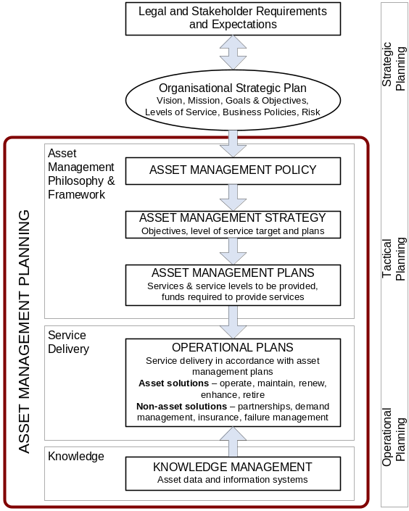

2. What Assets do we have?
Council uses infrastructure assets to provide services to the community. A select range of infrastructure assets and the services provided from the assets are shown in Table 1.
Table 1: Assets used for providing Services
Asset Class | Description | Services Provided
Water | Water mains, pump stations, PRV, reservoirs and other ancillary assets | Provide a reliable, efficient, and safe drinking water system for the community.
Sanitary | Sanitary sewer mains, lift stations and other ancillary assets | Underground carriage system specifically for transporting wastewater from houses and commercial buildings to treatment plant.
Drainage | Storm sewer network, culverts and other structures, such as debris basin, are the major drainage assets. | Carry overland drainage flows, natural streams and flood waters below earth fill structures to protect roads and properties from water damage.
Transportation | Roads, sidewalks, street bridges, traffic signals, street lighting, retaining walls and other engineering structures form the transportation network. | District’s transportation network helps motorists and pedestrians get safely from one point to another
Parks | All built facilities on parkland, including sports field assets, playgrounds, trails & pathways, bridges, parking lots, tennis courts, and other park structures. | A well planned, park network provide attractive places for play, rest and relaxation. The community views parks infrastructure as essential to their enjoyment and standard of living in the District
Buildings | Buildings range from complex community recreation centres and office/commercial buildings to simple ancillary buildings. | Buildings are required to accommodate the statutory based activities for the District as well as to support cultural, economic, and community development activities. In addition, the District currently owns, and periodically acquires, real estate holdings whose primary value is strategic for land development.
Vehicle and equipment | All the IT, engineering, fire, recreation equipment and vehicles | Various
Golf course | Northland golf course, Murdo Fraser | Recreation
Library materials | Library IT equipment, books, and other materials. | Education and learning

3. District Assets and their management

3.1 State of the Assets
Excluding land the District owns just over $2.1 Billion of assets that comprise the built environment. The financial status of Council’s assets is shown in Table 2. All values are at 2017 dollar value.
Table 2: Financial Status of the Assets
Asset Class | Replacement Cost ($M) | Annual RV depreciation  expense($M) *
Transportation | 712 | 5.7
Buildings | 364 | 9.1
Parks | 60 | 2.2
Vehicles & Equipment | 25 | 2.0
Technology | 18 | 1.3
Library | 4 | 0.6
Water | 384 | 5.6
Sanitary | 238 | 3.9
Drainage | 300 | 4.8
Grand Total | 2,105 | 35.2

Figure 1: Asset Replacement Values
Figure 1 below shows the percentage share of asset replacement values.
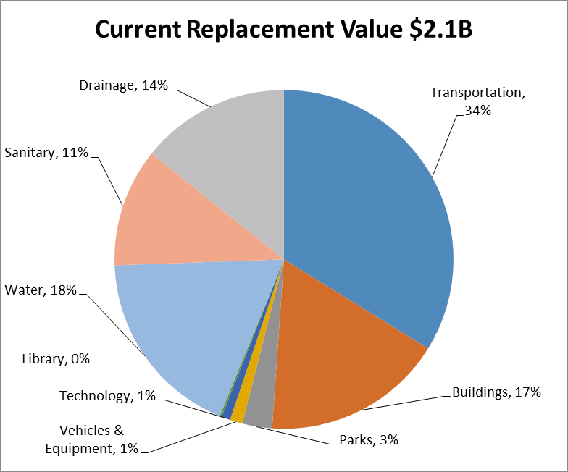
Figure 2: Asset Consumption Ratio
The Asset Consumption Ratio is one of eight short listed financial sustainability measures that were being considered between 2005 and 2012 as key sustainability indicators. While it is not one of the three financial sustainability measures adopted in 2012, as an international best practice benchmark it remains relevant and part of the asset management story on the built environment. The Asset Consumption Ratio profiles average proportion of “as new condition” left in assets.
The benchmark target is “greater than 40% and less than 80% “. This wide range is a generalized average that needs to consider local conditions, life cycle costs, agreed upon levels of service and risk management conditions. In isolation it can be viewed as a high level indicator of asset remaining life (based on physical condition).
“As new condition” means assets in both good and very good condition. In general terms, the lower the consumption ratio the greater the required investment in maintenance to sustain the assets. Assets in poor condition may still meet the required levels of service if planned maintenance is appropriate and reactive maintenance is contained.
Asset Consumption Ratios, for 2017, for each major asset network are shown in Figure 2.
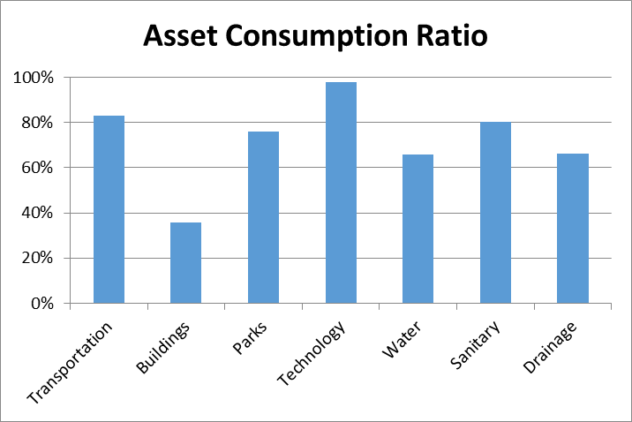

Figure 3: Remaining Asset Life
Remaining Asset Life is based upon straight line depreciation rates and is also the recommended approach that supports steady state funding of the built environment over the entire asset life cycle.
As best practices focus on life cycle costs over the entire life of an asset, substantial amounts of remaining life does not negate the need to think long term and sustain asset groups using steady state replacement funding augmented by strategic and holistic use of long term debt. Remaining Asset Life by major asset groups is in Figure 3 below.
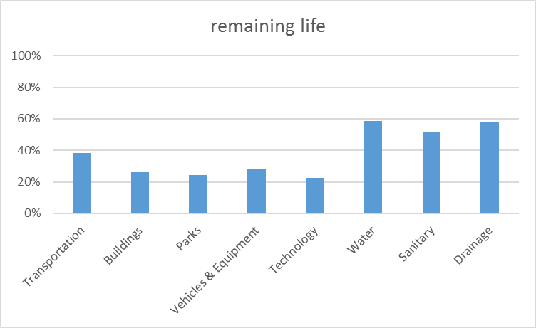
The District’s work with the FCS Group on our utility networks profiled the need to increase user fees to bring our life cycle investments in these asset groups into alignment with steady state replacement. FCS Group recommended best practices directed attention to:
  - Setting appropriate reserve levels
    - Reserve target set at $11-13 million
  - Understanding capital needs and funding gap
  - Aligning rate with consumption
    - Minor shifts pending more reliable date

In general terms, Transportation, Buildings and Parks asset networks have shorter lives and deteriorate faster than longer lived asset networks.

Figure 4: Asset Condition Profile
The District uses a Corporate Condition Measurement System (CCMS) that enables the comparison of assets within an asset group and across asset groups. The CCMS follows best practices that recommend a five point system. The District uses A - Very Good, B – Good, C – Fair, D – Poor and F – Very Poor. The CCMS measure physical, demand/capacity and functionality conditions.
The physical condition of each major asset network is in Figure 4 below:
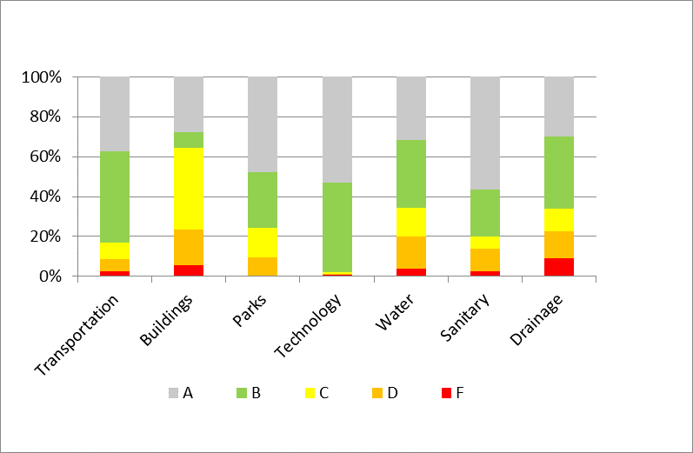

3.2 Life Cycle Cost

Life cycle costs (or whole of life costs) are the average costs that are required to sustain the service levels over asset life. Life cycle costs include operating and maintenance expenditures and asset consumption (depreciation expense).
Assets as at December 31, 2017 have a current replacement value of $2.1 billion. Average Life Cycle costs are comprised of Capital Renewal and Operating and Maintenance costs. For the assets that have been assessed via asset management plans life cycle costs total $71 million per annum (Table 3).
Table 3: Life Cycle Costs, in millions
Assets | Replacement Costs | Capital Renewal - Annual | Operation & Maintenance - Annual | Annual Life cycle Cost
Transportation | 712 | 6.8 | 2.4 | 9.2
Buildings | 364 | 15.2 | 5.0 | 20.2
Parks | 60 | 2.8 | 3.4 | 6.3
Vehicles & Equipment | 25 | 2.0 | 2.4 | 4.4
Technology | 18 | 1.3 | 3.5 | 4.8
Library | 4 | 0.6 | 0.8 | 1.4
Water | 384 | 6.3 | 4.0 | 10.3
Sanitary | 238 | 4.4 | 2.0 | 6.4
Drainage | 300 | 6.6 | 1.4 | 8.0
Grand Total | 2,105 | 46.1 | 24.8 | 70.9

Each asset management plan projects the best practice next 10 years expenditures (Table 4). These expenditure projections inform the District long term financial plan.
Table 4: Next 10 years projected expenditure, in millions, as at December 2017
Assets | 1 - Capital Renewal - annual | 2 - Operation & Maintenance - annual | Renewal Expenditure, per year (1+2) | New Assets & upgrade, per year
Transportation | 6.9 | 2.4 | 9.3 | 23.4
Buildings | 16.0 | 5.0 | 21.0 | 9.2
Parks | 3.0 | 3.4 | 6.5 | 6.6
Vehicles & Equipment | 1.9 | 2.4 | 4.4 | 0.0
Technology | 1.3 | 3.5 | 4.8 | 0.9
Library | 0.7 | 0.8 | 1.5 | 0.0
Water | 6.9 | 4.0 | 10.8 | 0.4
Sanitary | 1.6 | 2.0 | 3.6 | 1.2
Drainage | 3.3 | 1.4 | 4.7 | 1.2
Grand Total | 41.8 | 24.8 | 66.6 | 43.0

Average Life cycle costs compared to Next 10 years projected expenditure (Table 4) provide a high level indicator of long term sustainability in provision of services.
Next 10 years projected expenditure
- Will vary depending on the backlogs and/or timing of asset renewals.
- Is the base to develop Long Term Funding Plan and will be revised accordingly.
Table 5: Annual Average Life Cycle Gaps, in millions
1 | 2 | 3 | 4  2 – 3 = 4 | 5
Assets | Annual Average Life cycle Cost ($/per Yr) | Next 10 Year Renewal Expenditure ($/per Yr) | Gap ($/Yr) | Gap %
Transportation | 9.2 | 9.3 | 0.0 | 0%
Buildings | 20.2 | 21.0 | 0.0 | 0%
Parks | 6.3 | 6.5 | 0.0 | 0%
Vehicles & Equipment | 4.4 | 4.4 | 0.0 | 1%
Technology | 4.8 | 4.8 | 0.0 | 0%
Library | 1.4 | 1.5 | 0.0 | 0%
Water | 10.3 | 10.8 | 0.0 | 0%
Sanitary | 6.4 | 3.6 | 2.7 | 43%
Drainage | 8.0 | 4.7 | 3.3 | 41%
Grand Total | 70.9 | 66.6 | 4.2 | 6%

District asset management plans assess the entire asset life cycle cost of the built environment. Beyond the current ten year long term financial planning horizon costs will continue to rise particularly in District Buildings, Sanitary and Drainage systems. Steady state replacement strategies combined with best practice reserve levels augmented by strategic use of debt financing of major building renewals should address these longer term costs.
The Columns 4 and 5 above indicate the next 10 year expenditures are below the average annual life cycle costs by $4.2 million per annum or 6%. These costs are primarily in Sanitary at $2.7 million and Drainage at $3.3 million. Given the longer lives of Sanitary and Drainage systems and their low life cycle costs in their initial half-life, higher annual life cycle costs are reasonable at this time. Our longer term utility modelling work with FCS will continue moving us toward reasonable best practice reserve levels to manage these costs in a steady state replacement manner.
The 2019 to 2028 long term financial plan will focus on steady state renewal of the $66.6 million profiled in Column 3 above, as well as projects within approved strategic plans, asset upgrades and new assets that are evidence based and supported by community requirements.
Through the integration of asset management and long term financial plans, knowing the extent and timing of any required increase in outlays and service consequences will assist the District in providing service to the community in a financially sustainable manner.

3.3 Asset Sustainability
Infrastructure backlog is the cost of asset renewal needed to bring assets back up to target condition levels. The key best practice financial sustainability indicator of the infrastructure backlog is the Asset Sustainability Ratio. This ratio is defined as Capital outlays on renewing/replacing assets (net of proceeds on sale) and with a target value greater than 90% but less than 110% of replacement value depreciation over a rolling three year period. When this ratio is combined with Indicator #1 (the Operating Surplus Ratio – see page 2), it indicates the District is approaching fiscally sustainable operating levels but needs to address its infrastructure backlog.

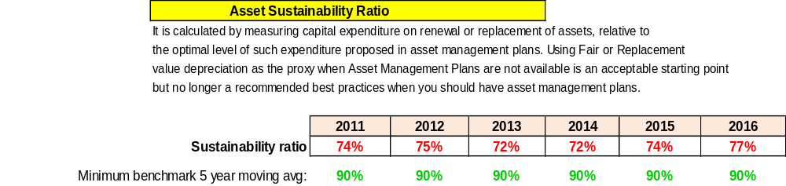

Since 2004 the District has been working toward this by placing 1% on the tax levy and recently increasing utility fees based on the work of the FCS Group. The District needs to continue to address its infrastructure backlog and monitor progress via the Asset Sustainability Ratio. Over the past five years the inability to achieve the minimum 90% Asset Sustainability Ratio target combined with a growing backlog of committed capital profiled in the District’s annual audited financial statements may indicate a resourcing gap in project delivery.

3.4 Asset Management Structure
Every major asset group is led by an asset manager that stewards the assets on behalf of Council.

3.5 Corporate Asset Management Team
The District has a ‘whole of organisation’ approach to asset management led by a corporate asset management team.
Champion:
- David Stuart, Chief Administrative Officer
Executive Sponsors:
- Andy Wardell, Acting General Manager, Finance and Information Technology & CFO
- Gavin Joyce, General Manager, Engineering, Parks and Utilities
Asset Management Steering Committee:
- Andy Wardell, Acting General Manager, Finance and Information Technology & CFO
- Steve Ono, Manager, Engineering Services, Deputy General Manager – Co-Chair
- Dan Milburn, General Manager, Planning, Properties & Permits – Co-Chair
- Committee Members
- Len Jensen | - Rick Danyluk
- Nicole Chevallier | - Andrew Durnin
- Shaun Carroll | - Rozy Jivraj
- Stephen Bridger  - Andrew Zhou | - Susan Rogers  - Shirley Young

The benefits of a corporate asset management team include:
- demonstrate corporate commitment to sustainable asset management,
- encourage corporate buy-in and responsibility,
- coordinate strategic planning, information technology and asset management activities,
- promote uniform asset management practices across the organisation,
- information sharing across IT hardware and software,
- pooling of corporate expertise
- championing of asset management processes,
- wider accountability for achieving and reviewing sustainable asset management practices.
The role of the asset management team evolves as organisation asset management maturity increases over several phases.
Phase 1 (done)
- strategy development and implementation of asset management program

Phase 2 (continuous)
- asset management plan development and implementation,
- reviews of data accuracy, levels of service and systems plan development
Phase 3 (continuous)
- asset management plans operationalized
- evaluation and monitoring of asset management plan outputs
- ongoing asset management plans review
- annual updates and integration of asset management plans into the long term financial plan
The current position on the District asset management team is:
- Phase 1 – 100% complete
- Phase 2 – 90% complete but also a continuous quality improvement and assurance process
- Phase 3 – A continuous quality improvement and assurance process

3.6 Financial & Asset Management Core Competencies
The Australia’s National Frameworks on Asset Planning and Management and Financial Planning and Reporting define 10 elements. 11 core competencies have been developed from these elements to assess ‘core’ competency under the National Frameworks. The core competencies are:
Financial Planning and Reporting

- Strategic Longer Term Plan | - Annual Report
- Annual Budget

Asset Planning and Management

- Asset Management Policy | - Levels of Service
- Asset Management Strategy | - Data & Systems
- Asset Management Plans | - Skills & processes
- Governance & Management | - Evaluation

Council’s maturity assessment for the core competencies is detailed in Appendix A and summarised in Figure 4. All 11 core competencies were last assessed by the Asset Management Steering Committee in 2015.

3.7 Strategy Outlook
- The District is well positioned to sustain the current levels of service for the next ten years. Starting in 2004, Council began to address its infrastructure backlog by placing 1% on the tax levy dedicated to sustaining the built environment. Within the next few years we expect the Operating Surplus Ratio (the first international best practice financial sustainability indictor benchmark) of the minimum of best practice of 0% (inclusive of fair value depreciation) to be sustained on a regular basis.
- The cost to bring infrastructure measured primarily in “Poor” and “Very Poor” condition back to satisfactory levels of service is estimated at $100 million (5% of our total asset base). Funding this “backlog” is addressed through the “1% Asset Renewal” policy and progress can be measured through the “Operating Surplus Ratio”.
- Council and management are now shifting beyond sustaining the existing built environment to fulfilling the OCP vision, addressing gaps in key strategic plans and prioritization of community demands for increased levels of service from infrastructure. This focus will also assess any significant renewals of major assets material enough that steady state funding may require alternative financing strategies.
- Council’s current asset management maturity is at ‘core’ levels but requires further work to improve data and systems, levels of service management and reporting and accountability and direction.
- Implementation of the OCP presents an opportunities to renew key assets in the Town Centres as the Centres are renewed.
4. Where do we want to be?

4.1 Council’s Vision, Mission, Goals and Objectives
Council has adopted a Vision for the future in the Official Community Plan (OCP).
Vision for 2030 - The District of North Vancouver: Inspired by nature, enriched by people
Key Principles within the OCP
Active Leadership - The District embraces opportunities and addresses challenges proactively, recognizing the key role of local government in defining its community.
Accountability and Responsible Governance - The District engages its residents, seeking open and transparent input into its decision-making, while demonstrating fiscal accountability through prudent management of our shared assets.
Sustainability for Future Generations - The District balances the environmental, social, cultural and economic needs of the community and is committed to its role in the stewardship of all that is valued for future generations.
Collaboration and Partnerships - The District recognizes the necessity and value of collaborating with Federal, Provincial, municipal and First Nation governments as well as agencies, educational institutions, social service organizations, and businesses.
The OCP sets goals and objectives to be achieved in the planning period. The goals set out where Council wants to be. The objectives are the steps needed to get there. Goals and objectives relating to the delivery of services from infrastructure are shown in Table 5.
Table 3: Goals and Objectives for Infrastructure Services
Goals | Objectives
Growth Management – Town Centres, Village Centres, Neighbourhoods and Transit Corridors | To ensure that the appropriate long term decisions are made for municipal infrastructure supporting growth.
Parks and Open Space Plan | To maintain a diverse, high quality parks and open space system that serves a range of community needs and protects the natural environment.
Transportation Plan | To respond to our changing needs and meet our social, economic and environmental goals by providing greater transportation choice.

Council’s Asset Management Policy defines the District vision and service delivery objectives for asset management in accordance with legislative requirements, community needs and affordability.

4.2 Asset Management Policy
Council’s Asset Management Policy defines the council’s vision and service delivery objectives for asset management in accordance with the Strategic Plan and applicable legislation.
The asset management strategy is developed to support the asset management policy and is to enable council to show:
- how its asset portfolio will meet the affordable service delivery needs of the community into the future,
- enable Council’s asset management policies to be achieved, and
- ensure the integration of Council’s asset management with its long term strategic plans.
The policy can be found on the District DJ under Corporate Policies.

4.3 Asset Management Vision
To ensure the long-term financial sustainability of the District, it is essential to balance the community’s expectations for services with their ability to pay for the infrastructure assets used to provide the services. Maintenance of service levels for infrastructure services requires appropriate investment over the whole of the asset life cycle. To assist in achieving this balance, the District Asset Management Steering Committee vision aspires to:
Develop and maintain asset management governance, skills, process, systems and data in order to provide the level of service the community needs at present and in the futures, in the most cost-effective and fit for purpose manner.
In line with this vision, the objectives of the asset management strategy are to:
- ensure that the District’s infrastructure services are provided in an economically optimal way, with the appropriate level of service to residents, visitors and the environment determined by reference to the District’s financial sustainability,
- safeguard District assets including physical assets and employees by implementing appropriate asset management strategies and appropriate financial resources for those assets,
- adopt the long term financial plan as the basis for all service and budget funding decisions,
- meet legislative requirements for all District operations,
- ensure resources and operational capabilities are identified and responsibility for asset management is allocated,
- provide high level oversight of financial and asset management responsibilities through Finance & Audit Committee reporting to council on development and implementation of Asset Management Strategy, Asset Management Plans and Long Term Financial Plan.
Strategies to achieve this position are outlined in Section 5.

5. How will we get there?
The Asset Management Strategy supports strategies that enable the objectives of the Strategic Plan, Asset Management Policy and Asset Management Vision to be achieved.
Table 4: Asset Management Strategies
No | Strategy | Desired Outcome
1 | Measurable progress toward the Asset Management Vision and Mission (see section 4.3) moving toward agreed upon service levels. | The long term implications of Council services and the built environment are considered in annual budget deliberations.
2 | Conduct an annual high level review of Council’s levels of service working first with internal stakeholders then other stakeholders | Appropriate resources to deliver services.
3 | Develop and annually review Asset Management Plans (AMP) covering twenty years (at least 10 years) for all major asset classes (80% of asset value) at current levels of service. | Infrastructure needed by the community and required funding to optimise ‘whole of life’ costs.
4 | Develop Long Term Financial Plan covering at least 10 years incorporating asset management plan expenditure projections with a sustainable funding position outcome. | Sustainable funding model to provide Council services.
5 | Integrating AMPS into the LTFP Incorporate Year 1 of Long Term Financial Plan revenue and expenditure projections into annual budgets. | Long term asset and financial planning drives budget deliberations.
6 | Annually review and update Asset Management Plans and Long Term Financial Plans after adoption of annual budgets. Communicate any consequence of funding decisions on service levels and service risks. | Council and the community are aware of changes to service levels and costs arising from budget decisions.
7 | Report Council’s financial position at Replacement Value using Australia’s National Asset Management Strategy (NAMS), the Australian Local Government Financial Sustainability Indicators and performance against strategic objectives in Annual Reports. Assets and depreciation leverage Canadian Public Sector Accounting Board standards but include replacement value. | Financial sustainability information is available for Council and the community.
8 | Ensure Council’s decisions are made from accurate and current information in asset registers, on service level performance and costs and ’whole of life’ costs. | Improved decision making and greater value for money.
9 | Report on Council’s resources and operational capability to deliver the services needed by the community in the Annual Report. | Services delivery is matched to available resources and operational capabilities.
10 | Ensure responsibilities for asset management are identified and incorporated into staff position descriptions. | Responsibility for asset management is defined.
11 | Leverage this AM Strategy, the Asset Management Steering Committee and Executive Sponsors to realise ‘core’ maturity for the financial and asset management competencies within 3 years. | Improved financial and asset management capacity within the District.
13 | Report to the Finance & Audit Committee of Council on asset management milestones, AM Strategy, AM Plans and LTFP. | Oversight of resource allocation and performance.

6. Asset Management Improvement Plan
The current tasks required to sustain ‘core’ financial and asset management maturity follow:
Table 5: Asset Management Improvement Plan
AMBC Roadmap | Ref | Task – with AMBC Roadmap reference | Responsibility | Target | Budget
1.0 Know your assets | 1 | 1.6 Data, software and tools strategy  Start AM process and technology improvement: capital planning process (GFOA whitepaper) and capital planning and analysis (Hubble Upgrade) | Andrew Zhou / Andrew Durnin | TBD | Existing + additional resources
2.0 Know your financial situation | 2 | 2.7 optimized capital plan  Complete 10 year Long Term Financial Plan for 2019-2028, and workshop for Council | Rick Danyluk | Spring 2019 | Existing Resources
4.0 Manage your asset lifecycle,  2.0 Know your financial situation | 3 | 4.5 lifecycle strategies – OM, renewal and new  2.3/2.5 future capital and OM costs  Update Asset Management Plans including new AMP for fleet and NSEMO; focus on OM analysis and impact | Asset Managers | Summer 2018 | Existing Resources
4.0 Manage your asset lifecycle,  1.0 Know your assets | 4 | 4.7 optimize treatment selections  1.6 Data, software and tools strategy  Storm water AM system: CAMN (Climate change and Asset Management Network) – FCM funded project, phase 2, lifecycle management | Stephen Bridger/Andrew Zhou | June 2019 | Existing Resources
5.0 Know the rules | 5 | 5.1 Strategic goals  Project prioritization, refresh case template, sample high level case, OCP Implementation review | Felim  Victoria  Dan | Summer 2018 | Existing Resources
5.0 Know the rules, | 6 | 5.2 Legislation, regulation, policy & standards  Revise AM policy, AM strategy and AM governance framework: CAMN (Climate change and Asset Management Network) – FCM funded project, phase 1 | AMSC | May 2018 and Jan 2019 | Existing Resources
6.0 Sustainability monitoring | 7 | 6.1 Sustainability assessment  Update and report out on key financial sustainability indicators through Annual Report – AMSC to produce five-year forecast with a focus on the Asset Sustainability Ratio (ASR) | Andy Wardell/ Charlene Grant  AMSC | Spring 2018 | Existing Resources
6.0 Sustainability monitoring | 8 | 6.3 demand management – alternative strategies  Explore options for accelerated implementation of some programs (e.g. Active Transportation) | Steve Ono, Larry Davis | TBD | Existing Resources
6.0 Sustainability monitoring | 9 | 6.2 Coordinating infrastructure works  Project management framework – based on review of best practices | Victoria | 2018-2019 | Existing + additional resources
6.0 Sustainability monitoring | 10 | 6.4 Emerging technology (innovation)  AMBC & GFOABC joint training session – ½ day workshop for GFOABC in fall 2018 | TBD | TBD | Revenue potential

Appendix A Asset Management Maturity Assessment

District of North Vancouver
NAMS.PLUS3
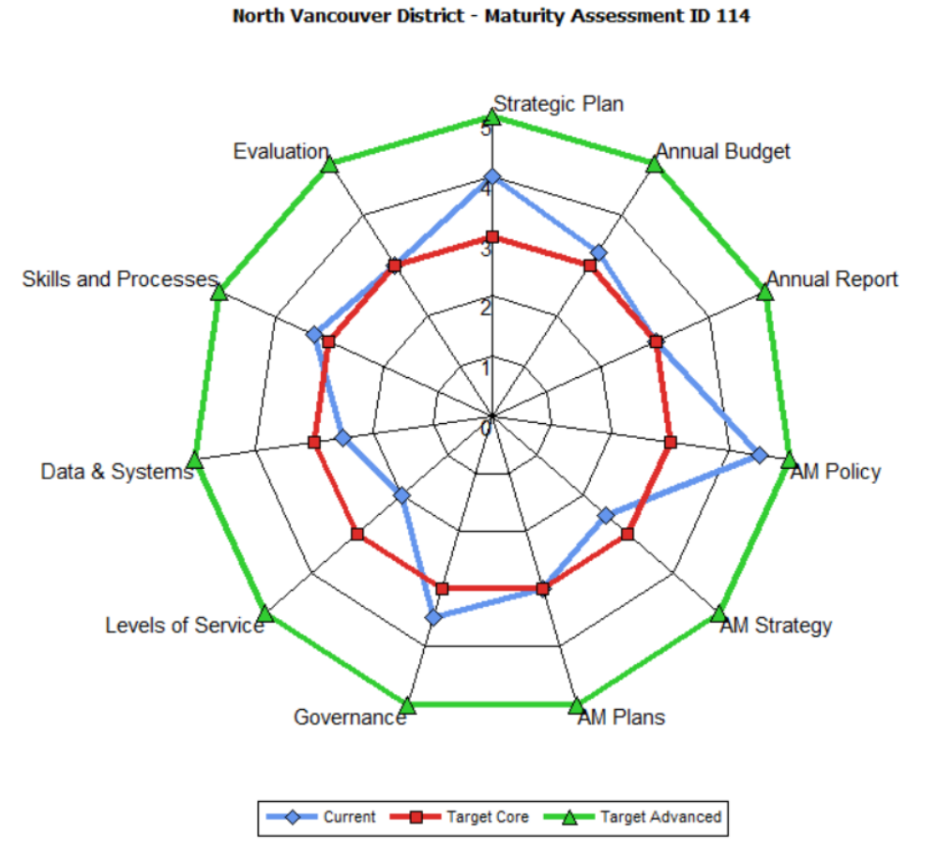
Maturity Assessment Model
In the absence of Canadian national standards, the District uses the asset management best practices developed by the Institute of Public Works Engineering AustralAsia (IPWEA).
The District assesses progress using the IPWEA NAMS.PLUS3 Maturity Assessment Model designed following Australian National Assessment Frameworks (NAF). These assessment frame works were developed to assist Local Governments determine progress in implementing Local Government Financial Sustainability Nationally Consistent Frameworks on Asset Planning and Management and Financial Planning and Reporting (LGFSF).
The NAMS.PLUS3 Maturity Assessment uses a series of questions that have been developed around asset management maturity competencies linked to the ten key elements (see the spider diagram) of the LGFSF. The questions were agreed between stakeholders to facilitate a nationally consistent evaluation of implementation. Key attributes of the model are it:
- Is designed around the asset management journey of a local government
- Assesses where a local government is on the asset management maturity curve
- Evaluates progress towards ‘core’ maturity in asset management and financial planning
- Provides a Maturity Assessment Report specific to each local government and aggregated reporting at regional, state and national levels.
Maturity scores range from 0 – 5.0 with 3.0 being core maturity assessment and 5.0 advanced maturity. The District’s first Maturity Assessment was last completed by the Asset Management Steering Committee in 2015.
The District’s approach is continuous improvement combining both top down and bottom up approaches with an emphasis on building a strong foundation of Asset Management Plans, Strategic Plans, confirming levels of service with the community and evaluating our skills and processes inclusive of succession planning. Our 2018 asset management objectives include full integration of all asset management plans into the Long Term Financial Plan and initiation of the levels of service pilots.

1 Framework 2 Asset Planning and Management, p 4 - In the absence of Canadian benchmarks the District of North Vancouver leverages Australian and New Zealand standards.
This Asset Management Strategy is supported by Asset Management Plans and Asset Risk Registers that integrate into the Long Term Financial Plan.
Using the IPWEA NAMS.PLUS3 Maturity Assessment Model
LGPMC, 2009, Framework 2 Asset Planning and Management, p 2.
In 2015, the District co-authored with the Province, UBCM, GFOA and AMBC an Asset Management Framework for BC local governments called “Asset Management for Sustainable Service Delivery, A BC Framework”.
This Asset Management Strategy is supported by Asset Management Plans and Asset Risk Registers that integrate into the Long Term Financial Plan.
Community Charter, Section 7 (c), Section 8 (2)
Most funding programs including Infrastructure Canada, the Federal of Canadian Municipalities,
NAMS Canada was incorporated in November 2015. Gordon Sparks, Professor Emeritus at the University of Saskatchewan is its first President and CEO.
IPWEA, 2009, AIFMG, Quick Guide, Sec 4, p 5.
Asset Planning and Management Element 2 Asset Management Strategy and Plans divided into Asset Management Strategy and Asset Management Plans competencies.
Canadian Accounting Standards are at historical cost where replacement value measures are required.

